

**MODULE 1**

**Reading and Writing Skills**

**Academic Texts and Texts and Text Structure**

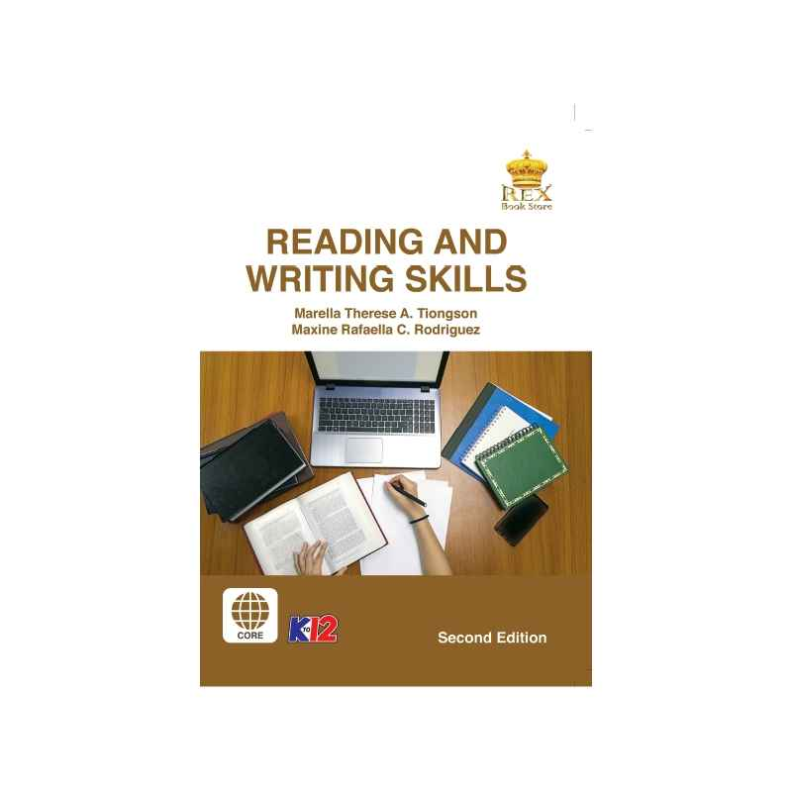

***Prepared by:***

**Mr. Reymart T. Metrillo**

Subject Teacher

**Name of Student**

**Grade,Section and Strand**

Date: ________________________

**MODULE 1:** **TEXT: A CONNECTED DISCOURSE and TECHNIQUES IN SELECTING AND ORGANIZING INFORMATION**

**I. TEXT: A CONNECTED DISCOURSE  
 DISCOURSE**

- An extended expression of thoughts or ideas

- Utterance, talk, speech, discussion, and conversation

- The ideas in discourse are not connected or do not have a particular structure

**TEXT**

- A large unit of written language

- A group of ideas put together to make a point or one central idea

- has a structure which requires the ideas in the discourse to be relevant to each other

- an actually connected discourse

**WORDS**

*Morphology*

- the study of words, how they are formed, and their relationship to other words in the same language

- analyzes the structure of words and parts of words, such as root words, prefixes, and suffixes

**Affix -** a morpheme that is attached to a root word to form a new word

**Prefix -** a morpheme that comes before a root word

Examples: auto- (automobile) in- (incorrect) over- (overcharge)

**Suffix -** a morpheme that comes after a root word

Examples: -ful (forgetful) -ish (childish) -ive (active) **Morpheme -** the smallest grammatical unit in a language

**Two Types of Morpheme**

**Free Morpheme**

**-** can function independently as a word

Examples: house, cat, blood

**Bound Morpheme**

- a word element attached to a root word (the main part of a word) to give it another meaning

- cannot function independently as a word

Examples: affixes (prefixes and suffixes)

**Compound Words -** combination of two different words

Examples:

**back + ward** = backward (towards the reverse direction)

***book + shelf*** = bookshelf (storage of books)

**full + moon** = full moon (a moon appearing as a bright circle)

**six + pack** = six-pack (often in reference to a pack of drinks)

***Context Clues***

- are words, phrases, and sentences that surround an unfamiliar word and help you recognize the meaning of an unknown word.

**Most Common Types of Context Clues**

**1. Synonyms** - used when the text has words or phrases that are similar in meaning to the unknown word

Example: The narrator in the poem was euphoric at his son's victory, for he cried out triumphantly when the boy came home.

Euphoric-victorious; triumphant; very happy and excited

**2. Antonyms** - words that reveal the opposite meaning in relation to the unknown word

Example: Although Mary was willing to play in the snow, Jack was reluctant because he was so cold.

Reluctant- not willing to do something; hesitant

**3. Examples** - are specific details in a text that are used to clarify the meaning of a word

Example: Projectiles include those items that are shot forward such as a cannon shell, bullet, or rocket.

***Projectiles-*** *things (such as bullet or rocket) that are shot from weapon*

**4. Definition** - is usually signaled by a form of the verb to be (am, is, are, was, were) or by commas or dashes

Example: The prisoner was in a state of wrath—a feeling of intense anger.

Wrath- extreme anger

**5. Explanation** - words or phrases that explain the unfamiliar word's meaning.

Example: Elis is a blithe young girl, because she always greets everyone with a smile.

Blithe - cheerful; happy, lighthearted

**II. TECHNIQUES IN SELECTING AND ORGANIZING INFORMATION**  
 **Brainstorming list** -is the most popular tool in generating creative and rich ideas

**1. Idea list** - involves writing the main topic and listing down the related ideas

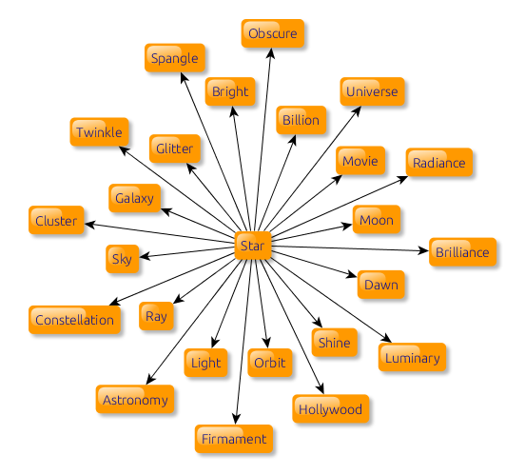

**2. Idea Map -**  a visual representation of ideas and their connections with one another

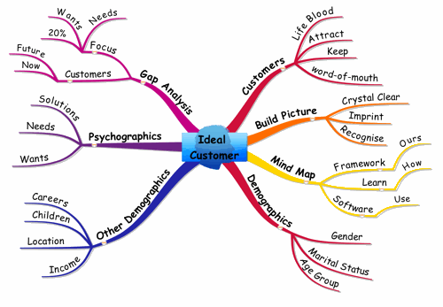

**GRAPHIC ORGANIZERS**

- are visual representations of concepts that help us structure information into organizational patterns.

**Types of graphic organizers:**

**1. Venn Diagram**-uses two or more overlapping circles to show similar and different attributes

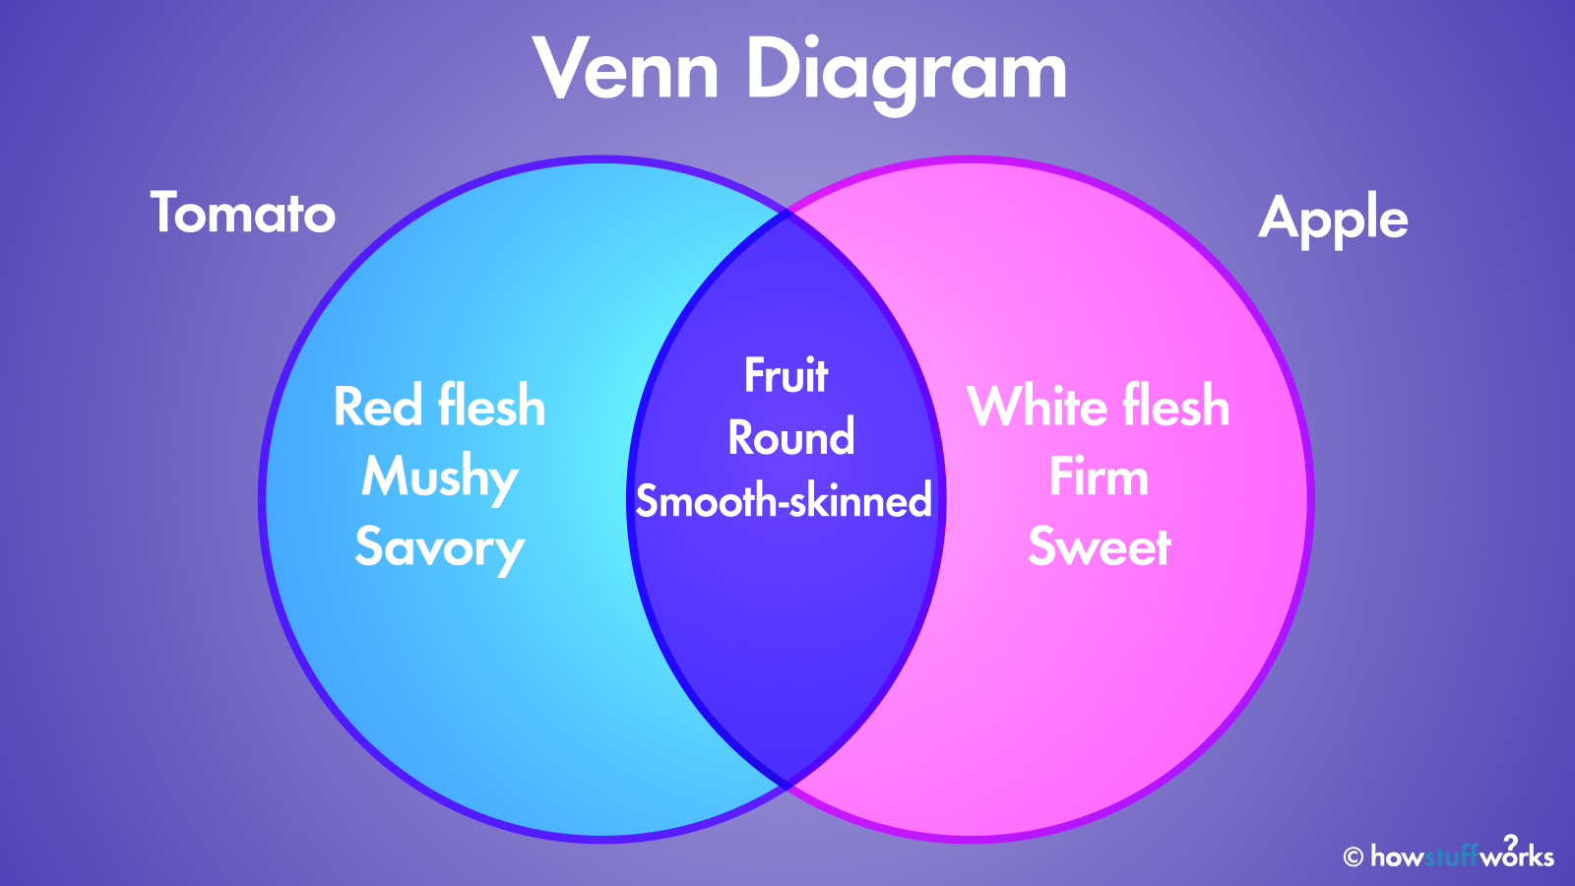

**2. Network Tree**- used to represent hierarchy, classification, and branching

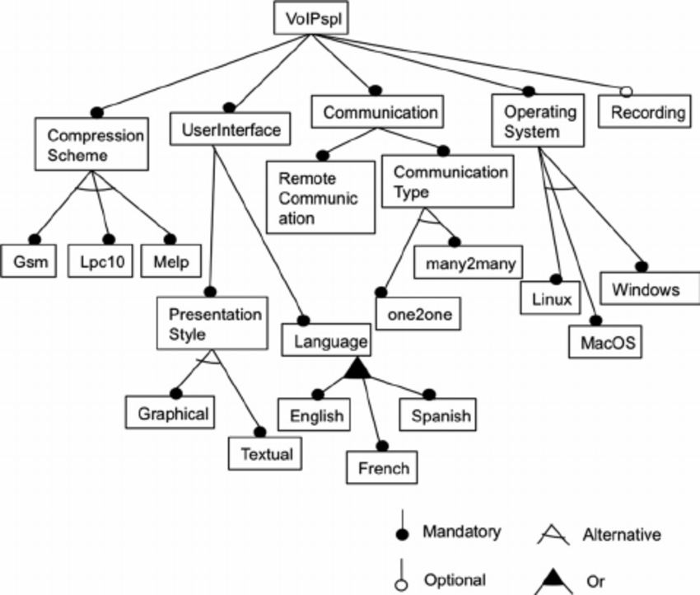

**3. Spider Map**-used to investigate and enumerate various aspects of a central idea, which could be a concept, topic, or theme; also known as semantic map

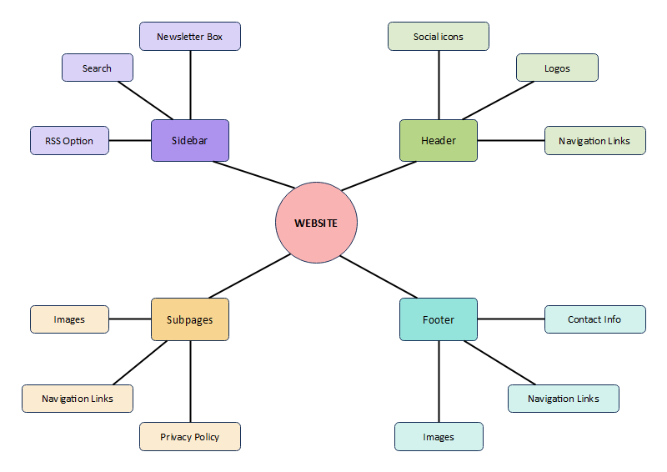

**4. Problem-Solution Map**-displays the nature of the problem and how it can be solved

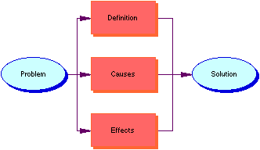

**5. Timeline**-used to show how events occurred chronologically through a long bar labeled with dates and specific events

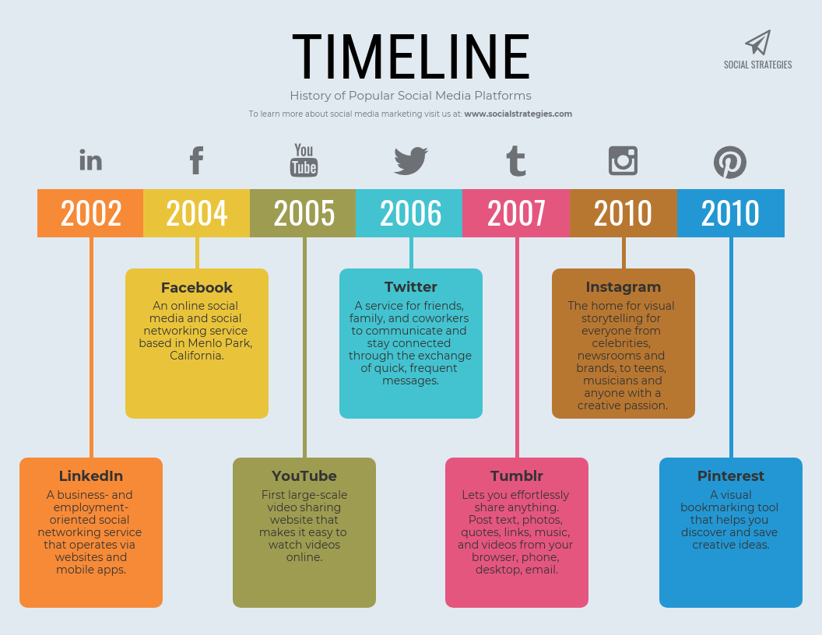

**6. Plot Diagram**-used to map events in the story; used to analyze the major parts of a plot7

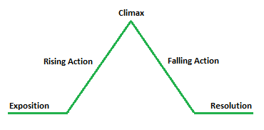

**7. Series of Events Chain**- used to show the logical sequence of events

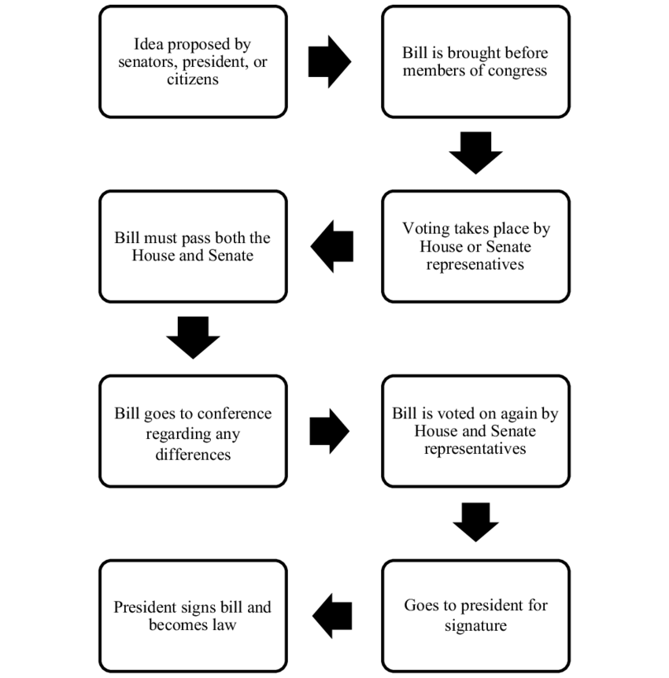

**8. Fishbone Map**-used to better understand the causal relationship of a complex phenomenon; shows the factors that cause a specific event or problem, as well as details of each cause

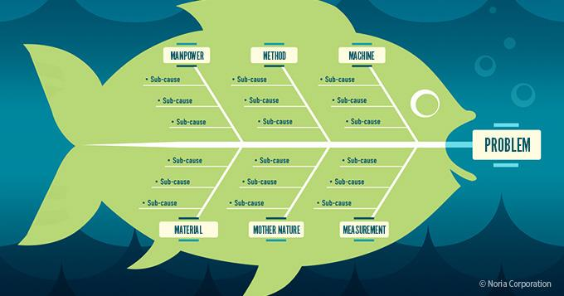

**9.Cycle-**describes how a series of events interact to produce a set of results repeatedly

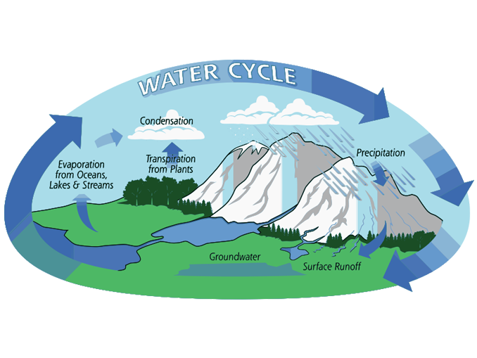

**10. Persuasion Map-**used to map out arguments and evidence that prove a viewpoint

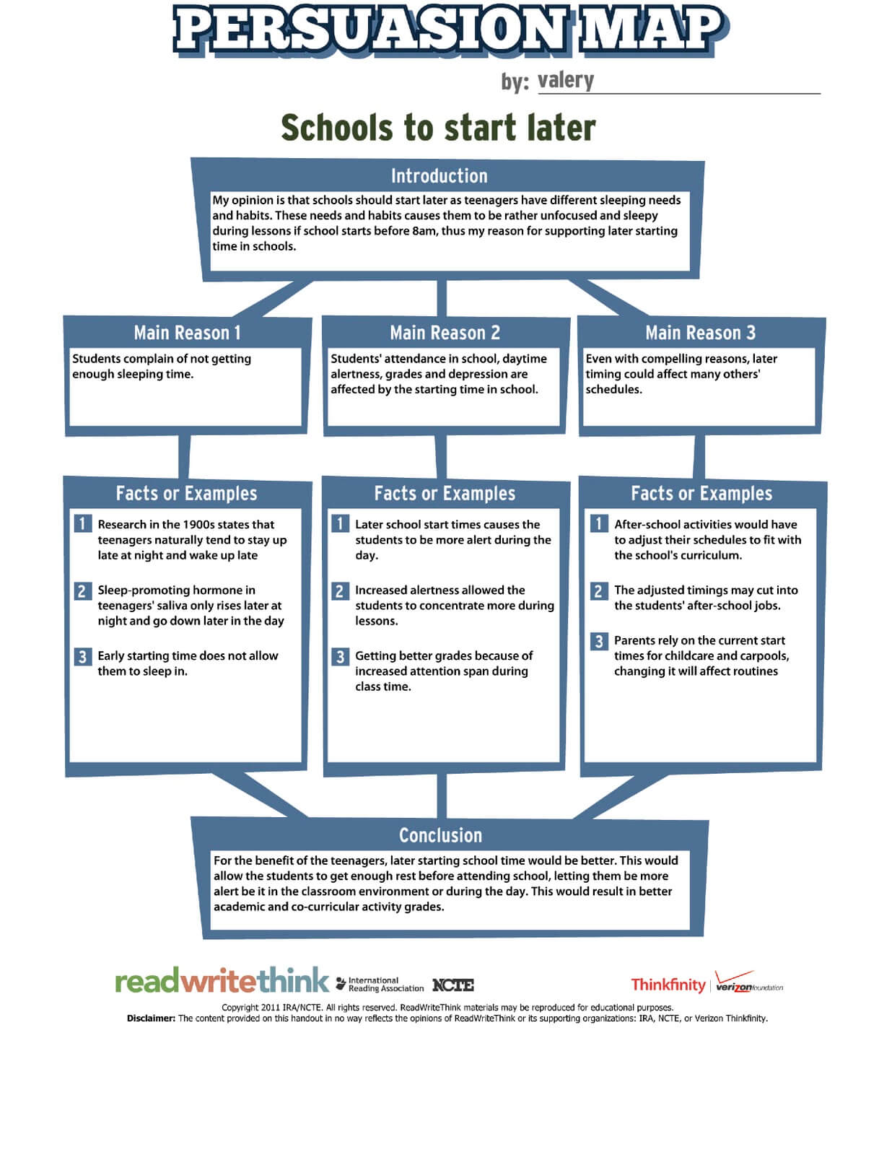

**Quiz 1 Part 1  
Direction:** Identify the following graphic Organizer

|  |  |
| --- | --- |
| 1. | 6. |
| 2. | 7. |
| 3. | 8. |
| 4. | 9. |
| 5. | 10. |

**Quiz 1 Part 2**

**Direction:** Rearrange the following jumbled word into a correct word. Each word has a corresponding meaning.

11. SMSNYOYN - used when the text has words or phrases that are similar in meaning to the unknown word

12. ELXNTNIOAPA – words or phrases that explain the unfamiliar word's meaning.

13. ATYOSMNN – words that reveal the opposite meaning in relation to the unknown word

14. IDEA PAM – a visual representation of ideas and their connections with one another

15. AEDI STIL – involves writing the main topic and listing down the related ideas

16. TETX – a large unit of written language - a group of ideas put together to make a point or one central idea

17. REUCOISDS – an extended expression of thoughts or ideas or an utterance, talk, speech, discussion, and conversation

18. EROEPHMM – the smallest grammatical unit in a language

19. FIAXF – a morpheme that is attached to a root word to form a new

20. POOCUMDN SRWDO – combination of two different words

**Activity 1  
Direction:** Read the short story The Winepress by Josef Essberger and organize the elements of the story. Using one of the graphic organizer, create a well organize details about the story.

**The Winepress**

*A short story by Josef Essberger*

Grapes"You don't have to be French to enjoy a decent red wine," Charles Jousselin de Gruse used to tell his foreign guests whenever he entertained them in Paris. "But you do have to be French to recognize one," he would add with a laugh.

After a lifetime in the French diplomatic corps, the Count de Gruse lived with his wife in an elegant townhouse on Quai Voltaire. He was a likeable man, cultivated of course, with a well-deserved reputation as a generous host and an amusing raconteur.

This evening's guests were all European and all equally convinced that immigration was at the root of Europe's problems. Charles de Gruse said nothing. He had always concealed his contempt for such ideas. And, in any case, he had never much cared for these particular guests.

The first of the red Bordeaux was being served with the veal, and one of the guests turned to de Gruse.

"Come on, Charles, it's simple arithmetic. Nothing to do with race or colour. You must've had bags of experience of this sort of thing. What d'you say?"

"Yes, General. Bags!"

Without another word, de Gruse picked up his glass and introduced his bulbous, winey nose. After a moment he looked up with watery eyes.

"A truly full-bodied Bordeaux," he said warmly, "a wine among wines."

The four guests held their glasses to the light and studied their blood-red contents. They all agreed that it was the best wine they had ever tasted.

One by one the little white lights along the Seine were coming on, and from the first-floor windows you could see the brightly lit bateaux-mouches passing through the arches of the Pont du Carrousel. The party moved on to a dish of game served with a more vigorous claret.

"Can you imagine," asked de Gruse, as the claret was poured, "that there are people who actually serve wines they know nothing about?"

"Really?" said one of the guests, a German politician.

"Personally, before I uncork a bottle I like to know what's in it."

"But how? How can anyone be sure?"

"I like to hunt around the vineyards. Take this place I used to visit in Bordeaux. I got to know the winegrower there personally. That's the way to know what you're drinking."

"A matter of pedigree, Charles," said the other politician.

"This fellow," continued de Gruse as though the Dutchman had not spoken, "always gave you the story behind his wines. One of them was the most extraordinary story I ever heard. We were tasting, in his winery, and we came to a cask that made him frown. He asked if I agreed with him that red Bordeaux was the best wine in the world. Of course, I agreed. Then he made the strangest statement.

"'The wine in this cask,' he said, and there were tears in his eyes, 'is the best vintage in the world. But it started its life far from the country where it was grown.'"

De Gruse paused to check that his guests were being served.

"Well?" said the Dutchman.

De Gruse and his wife exchanged glances.

"Do tell them, mon chéri," she said.

De Gruse leaned forwards, took another sip of wine, and dabbed his lips with the corner of his napkin. This is the story he told them.

At the age of twenty-one, Pierre - that was the name he gave the winegrower - had been sent by his father to spend some time with his uncle in Madagascar. Within two weeks he had fallen for a local girl called Faniry, or "Desire" in Malagasy. You could not blame him. At seventeen she was ravishing. In the Malagasy sunlight her skin was golden. Her black, waist-length hair, which hung straight beside her cheeks, framed large, fathomless eyes. It was a genuine coup de foudre, for both of them. Within five months they were married. Faniry had no family, but Pierre's parents came out from France for the wedding, even though they did not strictly approve of it, and for three years the young couple lived very happily on the island of Madagascar. Then, one day, a telegram came from France. Pierre's parents and his only brother had been killed in a car crash. Pierre took the next flight home to attend the funeral and manage the vineyard left by his father.

Faniry followed two weeks later. Pierre was grief-stricken, but with Faniry he settled down to running the vineyard. His family, and the lazy, idyllic days under a tropical sun, were gone forever. But he was very happily married, and he was very well-off. Perhaps, he reasoned, life in Bordeaux would not be so bad.

But he was wrong. It soon became obvious that Faniry was jealous. In Madagascar she had no match. In France she was jealous of everyone. Of the maids. Of the secretary. Even of the peasant girls who picked the grapes and giggled at her funny accent. She convinced herself that Pierre made love to each of them in turn.

She started with insinuations, simple, artless ones that Pierre hardly even recognized. Then she tried blunt accusation in the privacy of their bedroom. When he denied that, she resorted to violent, humiliating denouncements in the kitchens, the winery, the plantations. The angel that Pierre had married in Madagascar had become a termagant, blinded by jealousy. Nothing he did or said could help. Often, she would refuse to speak for a week or more, and when at last she spoke it would only be to scream yet more abuse or swear again her intention to leave him. By the third vine-harvest it was obvious to everyone that they loathed each other.

One Friday evening, Pierre was down in the winery, working on a new electric winepress. He was alone. The grape-pickers had left. Suddenly the door opened and Faniry entered, excessively made up. She walked straight up to Pierre, flung her arms around his neck, and pressed herself against him. Even above the fumes from the pressed grapes he could smell that she had been drinking.

"Darling," she sighed, "what shall we do?"

He badly wanted her, but all the past insults and humiliating scenes welled up inside him. He pushed her away.

"But, darling, I'm going to have a baby."

"Don't be absurd. Go to bed! You're drunk. And take that paint off. It makes you look like a tart."

Faniry's face blackened, and she threw herself at him with new accusations. He had never cared for her. He cared only about sex. He was obsessed with it. And with white women. But the women in France, the white women, they were the tarts, and he was welcome to them. She snatched a knife from the wall and lunged at him with it. She was in tears, but it took all his strength to keep the knife from his throat. Eventually he pushed her off, and she stumbled towards the winepress. Pierre stood, breathing heavily, as the screw of the press caught at her hair and dragged her in. She screamed, struggling to free herself. The screw bit slowly into her shoulder and she screamed again. Then she fainted, though whether from the pain or the fumes he was not sure. He looked away until a sickening sound told him it was over. Then he raised his arm and switched the current off.

The guests shuddered visibly and de Gruse paused in his story.

"Well, I won't go into the details at table," he said. "Pierre fed the rest of the body into the press and tidied up. Then he went up to the house, had a bath, ate a meal, and went to bed. The next day, he told everyone Faniry had finally left him and gone back to Madagascar. No-one was surprised."

He paused again. His guests sat motionless, their eyes turned towards him.

"Of course," he continued, "Sixty-five was a bad year for red Bordeaux. Except for Pierre's. That was the extraordinary thing. It won award after award, and nobody could understand why."

The general's wife cleared her throat.

"But, surely," she said, "you didn't taste it?"

"No, I didn't taste it, though Pierre did assure me his wife had lent the wine an incomparable aroma."

"And you didn't, er, buy any?" asked the general.

"How could I refuse? It isn't every day that one finds such a pedigree."

There was a long silence. The Dutchman shifted awkwardly in his seat, his glass poised midway between the table and his open lips. The other guests looked around uneasily at each other. They did not understand.

"But look here, Gruse," said the general at last, "you don't mean to tell me we're drinking this damned woman now, d'you?"

De Gruse gazed impassively at the Englishman.

"Heaven forbid, General," he said slowly. "Everyone knows that the best vintage should always come first."

**REFLECTION:**

The learners will write their personal insights about the lesson using the prompt below.

1. It is important to establish a good connection between your thoughts and idea?

2. Among the following graphic organizer, which is more useful and easy to use one? Why?